

## PHYSICS Stage 2

## YEAR 11

## Semester 1

**2014**

Name: _______________________________________________________

Teacher: ___________________________________________________

# *TIME ALLOWED FOR THIS PAPER*

## Reading time before commencing work: Ten minutes

Working time for the paper: **Two hours**

# *MATERIALS REQUIRED/RECOMMENDED FOR THIS PAPER*

**To be provided by the supervisor:**

* This Question/Answer Booklet; Formula and Constants sheet

**To be provided by the candidate:**

* Standard items: pens, pencils, eraser or correction fluid, ruler, highlighter.
* Special items: Calculators satisfying the conditions set by the Curriculum Council for this subject.

# *IMPORTANT NOTE TO CANDIDATES*

No other items may be taken into the examination room. It is **your** responsibility to ensure that you do not have any unauthorised notes or other items of a non-personal nature in the examination room. If you have any unauthorised material with you, hand it to the supervisor **before** reading any further.

All calculations are to be set out in detail. Marks may be awarded for correct equations and clear setting out, even if you cannot complete the calculation. Express **numerical answers** to three (3) significant figures and include units where appropriate. Express **estimates** to one (1) or two (2) significant figures, and state any assumptions clearly.

**STRUCTURE OF THE PAPER**

|  |  |  |  |  |  |
| --- | --- | --- | --- | --- | --- |
| Section | No. of  Questions | No. of questions  to be attempted | Suggested working time  (minutes) | Marks available | Proportion of  exam total |
| 1: Short Answers | 13 | ALL | 40 | 49 | 38% |
| 2: Problem Solving | 7 | ALL | 60 | 65 | 50% |
| 3: Comprehension and  Interpretation | 1 | ALL | 20 | 16 | 12% |

**INSTRUCTIONS TO CANDIDATES**

Write your answers in the spaces provided beneath each question. The value of each question (out of 130) is shown following each question.

The enclosed Physics: Formulae and Constants Sheet may be removed from the booklet and used as required.

Calculators satisfying conditions set by the School Curriculum and Standards Authority may be used to evaluate numerical answers. The calculator **cannot** be a “**graphics”** calculator.

Answers to questions involving calculations should be evaluated and given in decimal form. Final answers should be given up to three significant figures and include appropriate units where appropriate. Despite an incorrect final result, credit may be obtained for method and working providing these are clearly and legibly set out.

Questions containing specific instructions to **show working** should be answered with a complete, logical, clear sequence of reasoning showing how the final answer was arrived at; correct answers which do not show working will not be awarded full marks.

Questions containing the instruction "**ESTIMATE**" may give insufficient numerical data for their solution. Students should provide appropriate figures to enable an approximate solution to be obtained.

**Section 1: Short Answers**

Marks allocated: 49 marks out of a total of 130 (38%)

**Suggested working time: 40 minutes**

Attempt ALL questions in this section. Not all questions attract the same marks.

Answers are to be written in the space below or next to each question.

**Question 1 (3 marks)**

A drill bit is cooled by running cool water over it as it drills through a thick piece of steel. Why

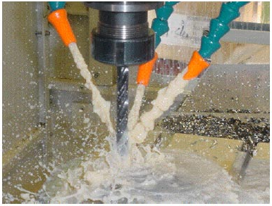is it necessary to have the water running over the drill bit and why is water used instead of oil to cool the drill bit?

**Question 2 (4 marks)**

For the following voltmeters read the scale, record the value on the scale, including units, and determine the uncertainty of the measurement.

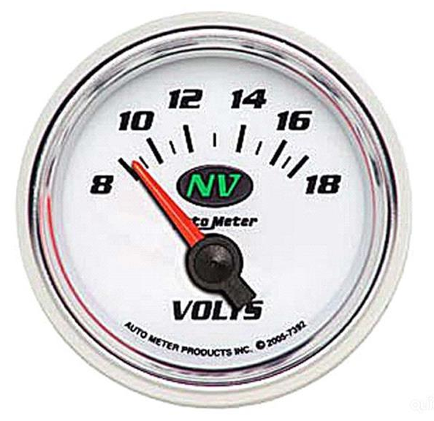

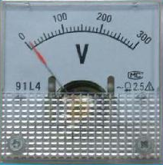

(a) Record the measurement __________ (b) Record the measurement _________

Record the uncertainty ___________ Record the uncertainty _________

**Question 3 (3 marks)**

A shop assistant opens a bottle of perfume to demonstrate the fragrance to a customer. Within a few seconds the smell of the perfume can be detected by another shopper who is standing several metres away. Using your understanding of the kinetic molecular theory, explain why the perfume can be detected several metres from the open bottle.

**Question 4 (4 marks)**

A tray containing 700.0 mL of water at 20.0 oC is placed in the freezer compartment of a refrigerator. How much heat must be removed from the water for it to become ice at -4.0 oC?

**Question 5 (3 marks)**

When a Bunsen burner is applied to a test tube as shown in the diagram, the water boils while the ice, held down by the metal gauze, only melts very slowly. Explain why this occurs?

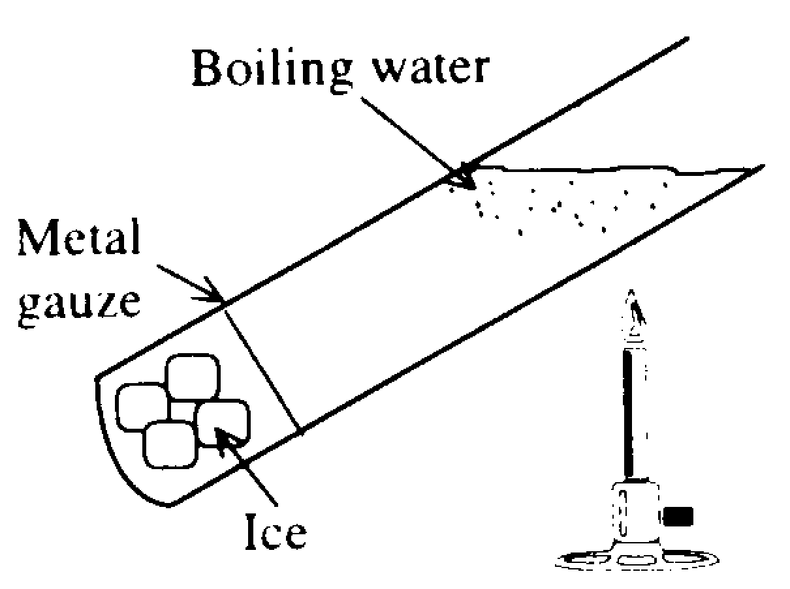

**Question 6 (4 marks)**

When it is not convenient to connect your iPad to the mains to recharge it, a portable charger (see opposite), can be used. A typical portable charger can deliver 3.0 V with a current of 1.9 A.

(a) If the device is connected to the iPad for 2.5 hours, how much charge flows from the power charger to the iPad in that time? (2 marks)

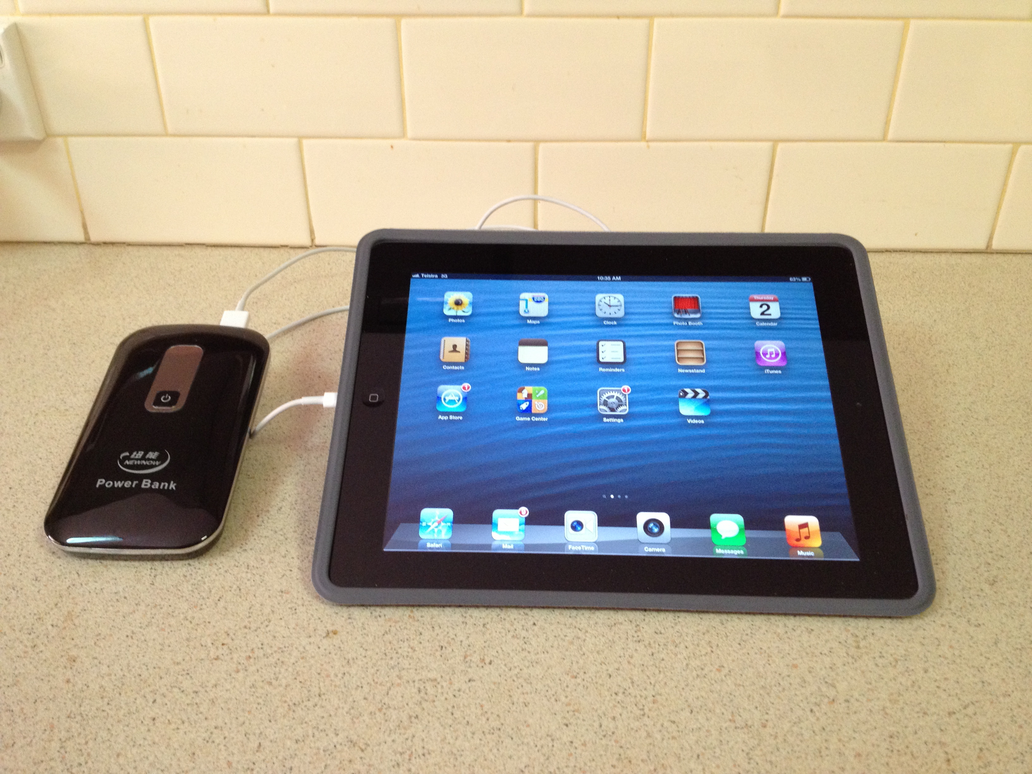

(b) How much work is done in moving the charge? (2 marks)

**Question 7 (3 marks)**

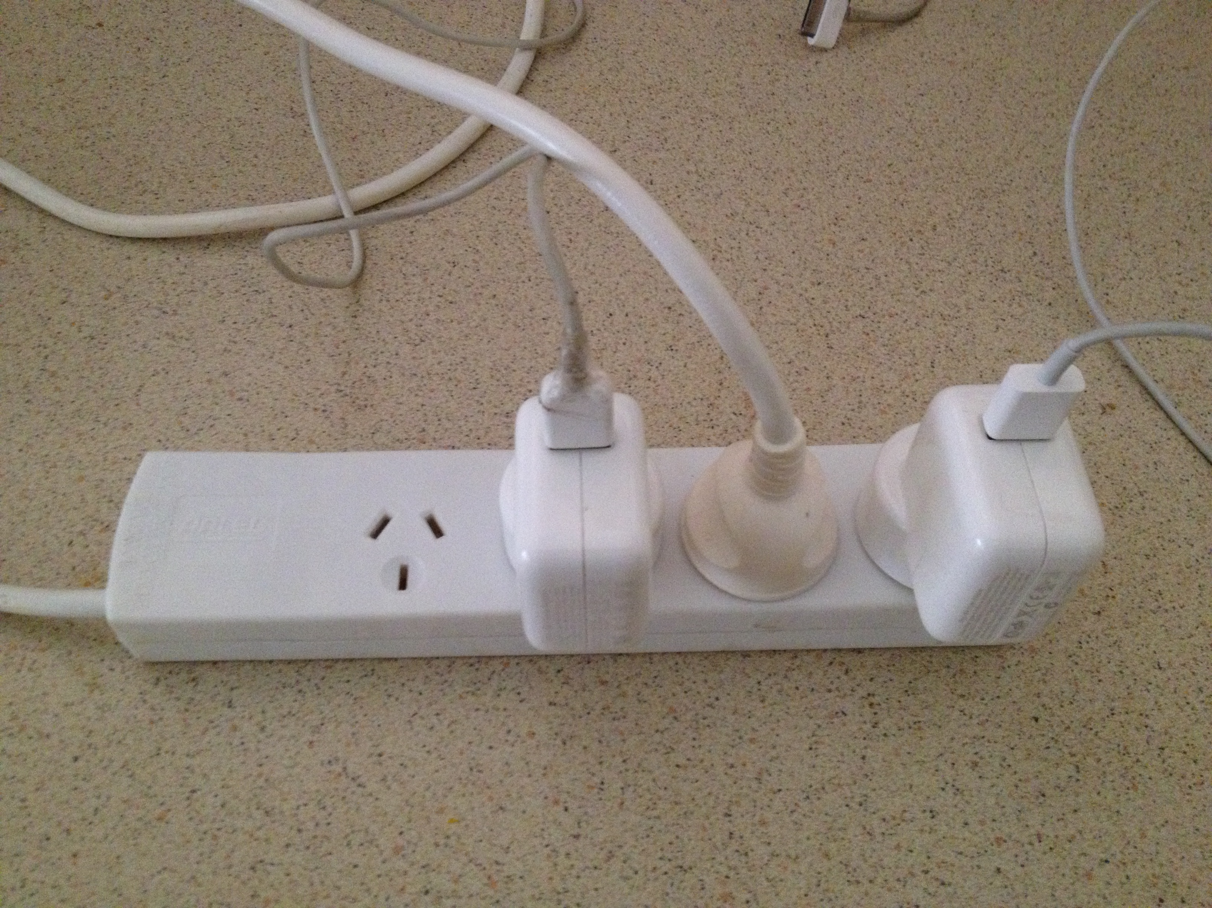

A four outlet power board (see photo opposite) used to connect a computer, printer and desk lamp to a single 240 V outlet, is rated for a maximum current of 8.00 A. Why shouldn’t a portable electric heater, rated at 240 V and 2.50 kW, be plugged into the fourth outlet on the power board? Explain, and support your answer with calculations.

**Question 8 (4 marks)**

Ammeters have ***low resistance***. They are always placed in ***series*** with the devices being investigated. Explain the reasons for these two facts. Use a diagram in your answer.

**Question 9 (6 marks)**

When a person touched the door handle of a car that had just been driven, they received a small electric shock.

(a) Describe the most likely conditions that contribute to the person receiving the shock. (2 marks)

(b) When a second person touched the handle they did NOT receive a shock. Suggest a reason why the second person did not receive a shock? (2 marks)

(c) Car tyres are impregnated with carbon. How does this reduce the likelihood that people will receive shocks when touching car door handles? (2 marks)

**Question 10 (3 marks)**

At the bank, the safe can only be opened by turning two switches. A separate key operates each switch. The same system is used in underground missile silos - two keys are needed to fire the missiles. Are these switches in series or parallel? Use a diagram to explain your answer.

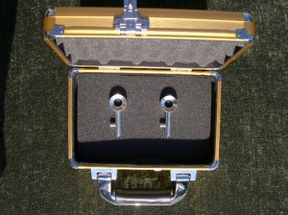

**Question 11 (3 marks)**

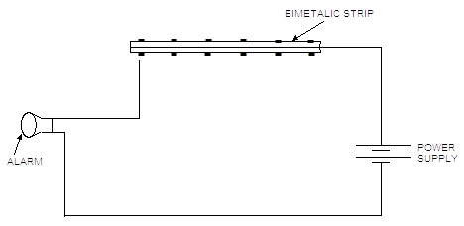Below is a diagram of a simple **thermostat** that will activate an alarm when the surrounding area is heated dangerously as in a fire. The bimetallic strip consists of two identical strips of different metals, riveted together.

Explain, in detail, the physics principles involved in this fire alarm.

**Question 12 (3 marks)**

Consider the following circuit.

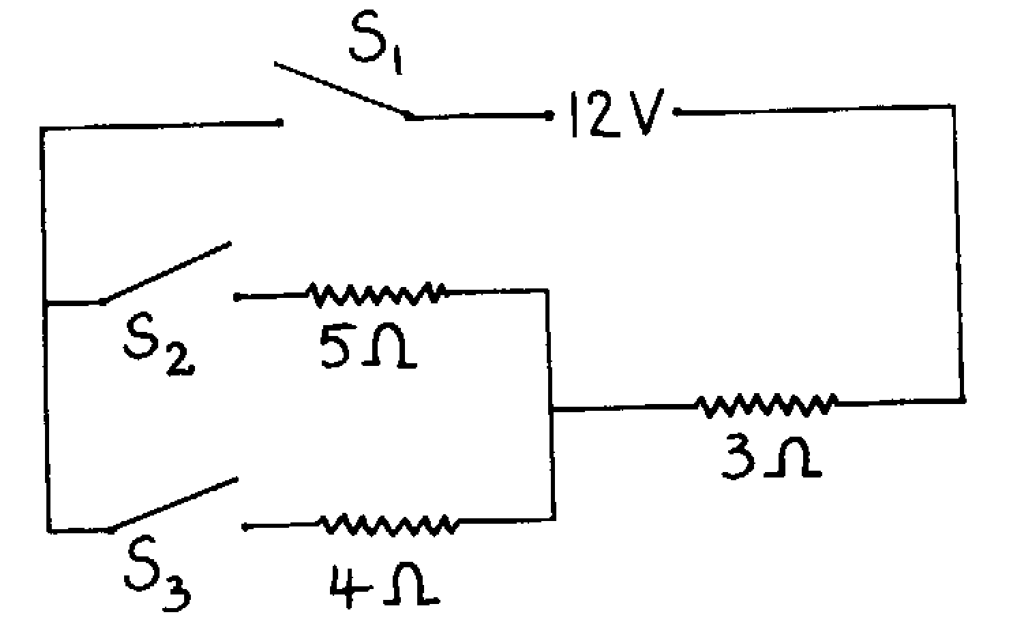

Calculate the current supplied by the power supply when

(a) S1 and S2 are closed while S3 is open;

(b) all three switches are closed.

**Question 13 (6 marks)**

A fast moving cricket ball hits the edge of a stationary bat transferring 18.1 J of energy to the bat.

(a) Describe in terms of the kinetic theory of matter how this transfer of energy occurs. (3 marks)

(b) The ‘hot spot’ image of the collision taken at the instant of impact shows that about

4.0 g of bat wood absorbs the 18.1 J of energy and increases the temperature of that portion of the bat. Estimate the temperature increase of that portion of the bat. (3 marks)

(The specific heat capacity of the bat wood is 2.25 x 103 J kg-1 K-1 )

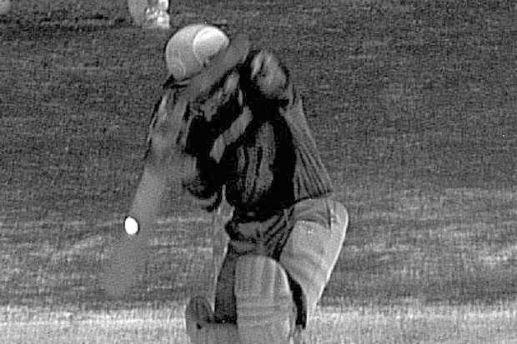

**END OF SECTION 1**

**Section 2: Problem Solving**

Marks allotted: 65 marks out of a total of 130 (50%)

This section contains 6 questions. Suggested working time 60 minutes

Answer the questions in the spaces provided.

**Question 14 (11 marks)**

The diagram below represents an electric circuit that has been set up to demonstrate various electrical concepts. The globes are identical in every way and each has a resistance of 20.0  and a power rating of 2.0 W. The power supply is set on 12.0 V. The circle “X” represents a meter.



(a) Calculate the total resistance in the circuit. (Ignore the internal resistance of the meter and the power supply) (3 marks)

(b) What is the reading on the meter labelled X. (include units)? (2 marks)

(c) Is the current flowing through globe 1:

(A) equal to,

(B) less than or

(C) more than,

the current flowing through globe 2? Support your answer with appropriate calculations. (4 marks)

(d) Is globe 1 operating at its maximum power output? Support your answer with appropriate calculations. (2 marks)

**Question 15 (11 marks)**

In an experiment to demonstrate how efficiently electrical energy is transformed into heat energy, a student set up an electrical circuit containing a nichrome wire heating coil immersed in a glass beaker of water. The circuit was switched on and the time to bring the water to its boiling point was recorded. A diagram of the circuit appears below.

**Data collected from the experiment:**

|  |  |
| --- | --- |
| Mass of water | 100.0 g |
| Mass of glass beaker | 20.0g |
| Initial temperature of the water | 21.0 oC |
| Time for water to reach boiling point | 20.0 min |
| Steady reading on the voltmeter | 12.0 V |
| Steady reading on the ammeter | 2.8 A |
| Specific heat of glass | 750 Jkg-1K-1 |



(a) Calculate the quantity of electrical energy produced by the circuit. (3 marks)

(b) Calculate the quantity of heat energy absorbed by the water. (3 marks)

(c) Calculate the efficiency of the system by comparing the measured energy input with the measured energy output. (2 marks)

(d) Explain why the efficiency is not 100%. (2 marks)

(e) Suggest one improvement that could be made to increase the efficiency of the system. (1 mark)

**Question 16 (6 marks)**

Some students conducted an experiment to determine the **latent** **heat of fusion of ice**.

They followed the method below

* Warm water was placed into a copper calorimeter and the temperature recorded.
* An ice cube at 0.00 °C was dried with a paper towel.
* The ice cube was placed in the warm water in the calorimeter and the final temperature was recorded when the melted ice, the water and the calorimeter had reached thermal equilibrium.
* Results were recorded in the table below.

|  |  |
| --- | --- |
| **Measurement** | **Data** |
| Mass of copper calorimeter | 73.0 g |
| Mass of calorimeter + warm water | 159 g |
| Mass of calorimeter + warm water + ice | 193 g |
| Mass of warm water |  |
| Mass of ice |  |
| Initial temperature calorimeter + warm water | 41.6 °C |
| Final temperature calorimeter + warm water + melted ice | 9.00 °C |
| Temperature change calorimeter + warm water |  |
| Initial temperature of ice | 0.00 °C |
| Temperature change of melted ice (water) in calorimeter |  |

(a) Complete the table by filling in the blanks. (Some of the values have been done for you.) (2 marks)

(b) Use this data to **calculate** the latent heat of fusion of ice in this experiment. (4 marks)

* + - * *The specific heat capacity for copper is 3.80 x 102 J kg-1 K-1*

**Question 17 (12 marks)**

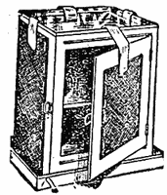When miners were prospecting in the Outback in the 1880s they kept their food cool by using a Coolgardie safe.

This consisted of a wooden box covered in a hessian(fibrous) material which absorbed water and was kept wet by a water reservoir on top.

1. Explain how the Coolgardie Safe maintained a cool temperature inside when a breeze was blowing. (2 marks)

Coolgardie Safe

1. Today’s modern evaporative air conditioners work in a similar way to the Coolgardie Safe.

In one such air conditioner 15.0 g of water evaporates in one minute.

(i) What amount of heat must be absorbed by this mass of water in order to evaporate?

(2 marks)

(ii) The heat needed to evaporate the water is absorbed from the air in a living room which

has dimensions 3.5 m x 5.2 m x 6.1 m. If 1 m3 of air has a mass of 1.22 kg, calculate the mass of air in the room. (2 marks)

(iii) Given that the specific heat capacity of air is 995 Jkg-1K-1, calculate the change in

temperature of the air in the living room due to the evaporation of this amount of water.

(2 marks)

(iv) Evaporative air conditioners do not work very well in regions of Australia where there is high humidity. Explain why this is so. (2 marks)

1. A freezer in a house runs on a power of 155 watts. Estimate the cost of running the freezer for a year if it is on for an average of 3 hours a day. The cost of electricity is 22.6 c per kWh. (2 marks)

**Question 18 (11 marks)**

The electricity supply from a household wall socket is not the same as that from a battery.

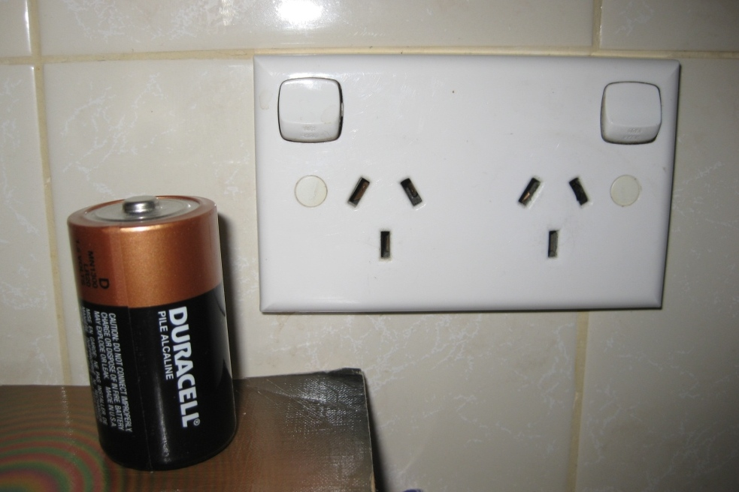

1. Describe two electrical characteristics of the household wall socket that are different to the battery. (2 marks)
2. Electric shock is hazardous to the human body. Describe why a person receiving an electric shock is in danger. (2 marks)
3. What is the value of the potential difference between the Earth wire and the Neutral wire in a household electrical circuit? (1 mark)
4. Identify (circle) the connection to Earth on this picture of a wall socket.

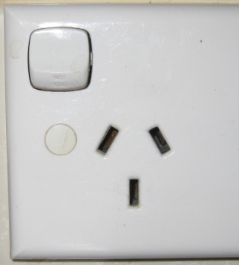(1 mark)

1. Describe the function of the Earth wire in a household electrical circuit.

(2 marks)

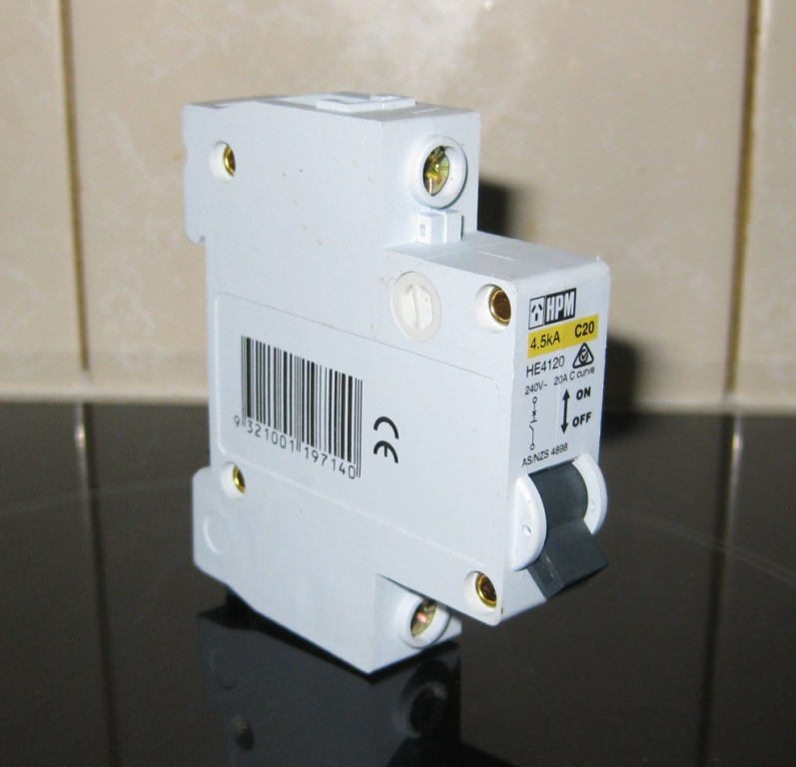A household electrical circuit includes components that protect people when using electrical devices. The fuse has now been replaced by circuit breakers and residual current devices in new homes.

1. Choose either a ‘circuit breaker’ or a ‘residual current device’ and describe how it protects people from electric shock and why it is better than a fuse. (3 marks)

**Question 19 (14 marks)**

An electrical circuit is set up by a teacher to test students understanding of current, resistance and potential difference (voltage). The meters used in the circuit do not have any influence on the circuit other than to register current and potential difference. The students could see the readings on five of the meters but the teacher had covered the dials of three of the meters so the students could not see what they registered. A diagram of the circuit is below



(a) Calculate what the readings on the three meters would be, and write the values next to the meters in the spaces provided. (3 marks)

(b) Calculate the resistance of X. (2 marks)

(c) Calculate the quantity of charge which flows through resistance Y in 5.0 minutes. (2 marks)

(d) Calculate the effective resistance of the combination of resistors M, N and Q. (2 marks)

(e) Calculate the value of resistance R (3 marks)

(f) Calculate the current flowing through resistor N. (2 marks)

**Section 3: Comprehension** (Marks allocated: 16 marks out of 130 (12%)

**Suggested working time 20 minutes**

This section has one (1) question. You must answer this question. Write your answer in the spaces provided.

When estimating numerical answers, show your working or reasoning clearly. Include units where appropriate.

**Thermal Conductivity**

*Paragraph 1*

If a bar of metal is placed so that one end of it is in contact with an object kept at a high temperature and the other end kept in contact with an object at a low temperature, then heat will flow through the rod. How much heat flows depends on additional factors. If the bar is cold when it is placed in position then to begin with the temperature of the bar will rise at the hot end. Heat will flow towards the cold end and this will gradually raise the temperature of the bar, but it is never possible for the whole of the bar to reach the temperature of the hot object. When the temperature of each part of the bar has stopped rising, the bar is said to be in the steady state. No heat will subsequently be used to raise the temperature of the bar itself The final temperature achieved at different points along the bar will depend on how the bar is lagged, as shown in the diagrams below.

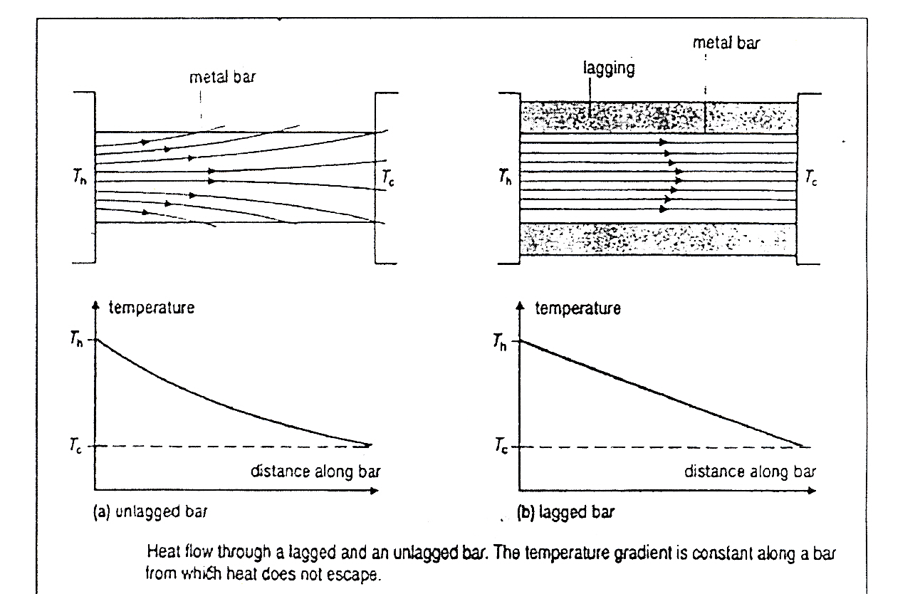

*Paragraph 2*

If heat escapes through the sides of the bar, then there is a greater flow of heat through the bar near the hot end than there is through the cold end. This means that there must be a larger temperature gradient near the hot end than near the cold end. The variation of temperature with distance is not linear. If perfect heat insulation is imagined around the bar, then no heat escapes through the sides and the rate of heat flow must be the same at all points along the bar. This parallel flow of heat in the steady state implies that the temperature gradient must be constant.

*Paragraph 3*

In the steady state it is found experimentally that the rate of flow of heat, Q/t, depends on the material of the bar and is proportional to;

the cross-section area of the material, A &

the temperature gradient.

For parallel flow, the temperature gradient is the difference in temperature between the ends of the bar divided by x, the length of the bar. Here it does not matter whether the temperatures are measured in Kelvin or degree Celsius. A temperature difference is normally quoted in Kelvin even though it is likely that when measurements are made of the temperatures at the ends of the bar the readings are taken in degrees Celsius.

*Paragraph 4*

If Th is the Kelvin temperature at the hot end of the bar and Tc the temperature at the cold end then

Q = λ A (Th - Tc)

t x

where λ is a constant called the thermal conductivity of the material.

λ is a constant which has units. To find the SI unit, λ can be made the subject of the equation giving:

λ = Q x

t A (Th - Tc)

Some numerical values of A, for some common substances are given in the table below.

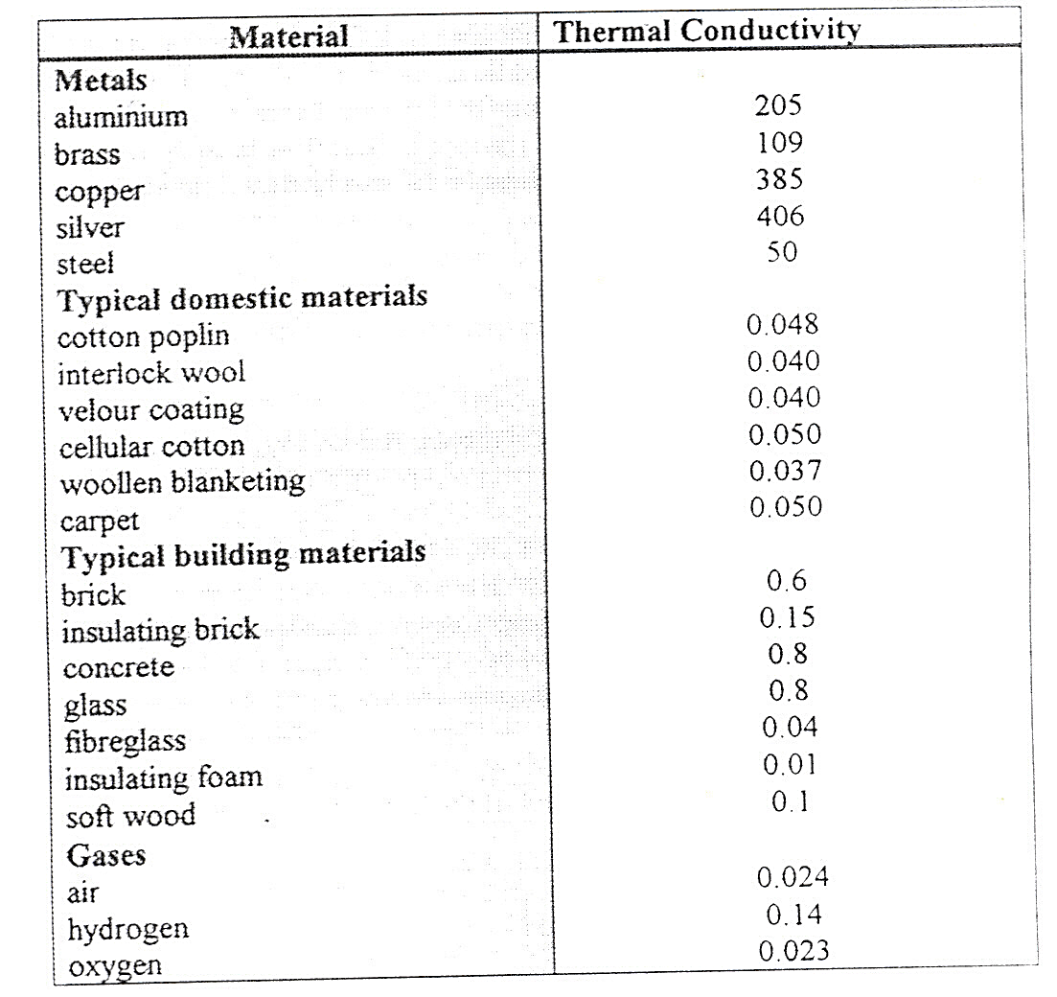

Questions

1. Why does it not matter if the temperature of parallel flow is measured in Kelvin or degrees

Celsius? *(paragraph 3)* (2 marks)

2. What are the SI units for thermal conductivity (λ)? *(paragraph 4)* (2 marks)

1. Which of the graphs (a) unlagged bar or (b) lagged bar represents flow of heat in the steady

state? Explain your answer. (2 marks)

1. If an unknown material which has a cross sectional area of 10-3 m2, a temperature gradient of

50 K, a length of 0.1 m and a heat rate flow of 100 J s-1 is tested is the material more

likely to be a metal or a gas? Support your answer with a calculation. *(paragraph 4)*

(3 marks)

5. Why is it not possible for the whole of the bar to reach the temperature of the hot object?

*(paragraph 1)* (2 marks)

6. In the context of the article, explain what is meant by the term “steady state”. (2 marks)

7. Explain in terms of the kinetic theory of matter, why the thermal conductivity of air is 0.024

but the thermal conductivity of brass is 109. (2 marks)

8. What is another term that could be used for the word “lagging”? (1 mark)

**END OF EXAMINATION**